MODULE 3: WIC NUTRITION ASSESSMENTS
April 22, 2014

Module 3 Page: Introduction
Narration: You’re now about to take the third step down the path of Nutritional Assessment by learning about how to implement parts A, B, C, and E of the ABCDE Guide. You’ll also get ready to learn about the tools in Section D of the Guide. As you know, your assessment goal is to provide the nutrition education, breastfeeding support, referrals, and food package tailoring that’s right for each client.
In Module 3, you’ll learn how to use the Nutrition Assessment Guide in the lab to ask the right questions and help your client get the resources she needs. Before getting started, you might want to review your notes from the course you’ve already taken on WIC Codes, and take a look at what you’ve already learned about OARS from the WIC PCE Course. Everything you learned in those courses will come into play as you move forward.
Design

Narrator
Welcome to Module 3

ABCDE Guide
You’ll Dig into Parts A, B, C, and E of the Nutrition Assessment Guide
You’ll Prepare to Learn About the Tools in Section D of the Nutrition Assessment Guide

Questions
You’ll Learn to Ask the Right Open-ended Questions

Typing WIC Codes
You’ll Learn More About WIC Codes

Happy Client
You’ll Learn How to Better Understand Your Client’s Concerns
You’ll Help Your Client Get Resources She Needs

Narrator
Bring on a sheet of paper with the follow in a check box list, and have the three checked and leave Assessment unchecked.
WIC Codes
OARS
WIC PCE

Interactions
None
Media/Graphics

Narrator  #11838, Melanie2 | ABCDE Guide  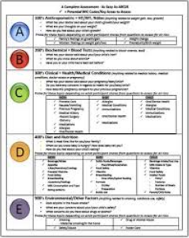 | Questions  iStock 000026573948
Typing WIC Codes  iStock 000002086476 | Happy client  iStock 000013098018

Module 3 Page: Using the Guide to Collect Clues and WIC Codes
Narration:
As you go through the Nutrition Assessment process, you’ll pick up a lot of clues about your client, her needs, her concerns, and her priorities. You’ll also use OARS skills to learn more about her strengths, challenges or motivations.
Many of the clues you’ll discover during your assessment can’t be used right away. You’ll record those clues, and use them later when deciding what type of nutrition package to offer to the family or client.

Sometimes you’ll make a note of the clues in writing on your note tracker. More often though, you’ll keep track of your clues through WIC Codes.

WIC Codes represent nutrition behaviors or conditions that affect a person’s nutrition status. The USDA has identified these codes as areas that make a person eligible for WIC. In other words, individuals with any of these codes may benefit from the nutrition education and support WIC offers.

Design

Detective
You’ll Pick Up Clues about Your Client

Listening
You’ll Use OARS Active Listening Skills
You’ll Use Your Professional Knowledge

[Show images together taking half the screen and the labels to the side of the images.]

Taking Notes
You’ll Record Some Clues in Your Note Tracker

Computer
You’ll Record More Clues as WIC Codes

USDA Logo
WIC Codes Are Required by USDA
Clients Who Have WIC Codes May Benefit from WIC Services

Interactions: None

Media/Graphics

you’re a detective  istockphoto file 1705380 | Nutrition Assessment Guide | Active listening/OARS  istockphoto file 4852019
take notes  istockphoto File #1625924  Put her over an office background. | record WIC Codes  iStock #15021592 | USDA  http://www.nifa.usda.gov/about/offices/nifa_logo.html

Module 3 Page: Your Goals and How to Reach Them
Narration:
You know that your assessment goal is to provide the nutrition education, breastfeeding support, referrals, and food package tailoring that’s right for each client. But how do know what’s right for each client, and when to offer WIC resources?
The ABCDE Guide helps you collect the information you need, and provides a guide for taking notes. WIC codes provide you with clear guidance for recording health concerns. Client responses to open ended questions will also clue you in to particular needs.
Unless you learn of an issue that needs immediate response, you’ll wait until the end of your assessment to offer education, referrals, support, and a food package. As you learn more, you’ll get a better sense of what your client needs right away, what she may need at a later date, and what she is ready to hear. For example, a client may have challenges with getting enough iron in her diet, but you may decide that it’s more urgent to help her learn to breastfeed her infant. You might offer her breastfeeding help today, but make a note that, at her next visit, she will need more education about iron-rich foods.
Design:

Scratching head and wondering

How Do You Know What’s Right for Each Client?
How Do You Know When to Offer WIC Resources?

ABCDE
The ABCDE Guide Helps You Collect Information and Take Notes
WIC Codes (computer)
WIC Codes Provide Guidance for Collecting and Recording Health Concerns
Asking Questions
Client Answers to Open-ended Questions Clue You In to Particular Needs
Physical Abuse or Serious Medical Issues Need Immediate Referrals
Most Client Needs Can Be Addressed at the End of the Assessment
Help with Breastfeeding
What Is Your Client Ready to Hear?
What Are Your Client’s Most Pressing Needs?
Which Client Needs Can Wait Until Next Visit?

Interactions:

None

Media Graphics:

wondering woman  istockphoto file 5513298 | Nutrition Assessment Guide | WIC Codes  istockphoto file 6566754
asking questions  video 7 scene 2 6  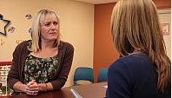 | breastfeeding  istockphoto file 26573948

Module 3 Page: Self-Check 1

Narration: Choose the answer which best answers the question, “Why do we use the ABCDE Guide when counseling clients? Then click ‘SUBMIT’ to check your answer.

Design:

Multiple choice question

Interaction:

[instructions] Choose the answer which best answers the question, “Why do we use the ABCDE Guide when counseling clients? Then click ‘SUBMIT’ to check your answer.

- Because it was developed by the National Institutes of Health
- Because it is very simple to use
- Because it is the only way to conduct assessments
- Because it is ensures that we cover the WIC Codes that USDA requires in an assessment.

Feedback:

Incorrect. The ABCDE Guide was created based on codes developed by the USDA. Try again!

Incorrect. Using the ABCDE Guide ensures that we cover the WIC Codes that USDA requires in an assessment.

Correct. Using the ABCDE Guide ensures that we cover the WIC Codes that USDA requires in an assessment.

Media/Graphics:

Module 2 Page: Using Sections A, B, C, and E of the Nutritional Assessment Guide

Narrator: You’re ready to get started using the Nutritional Assessment Guide. We’ll start with sections A,B,C, and E. We will save the D section for later because it has some special parts that we will go over separately.

As we go through each section of the guide we will discuss important questions you need to ask about, what to do with that information and the risk factors associated with each category. We’ll also point out whether you or the computer will assign these risks, and whether or not the risks are considered high risk and would require a referral to the Registered Dietitian.

Design Notes:
Puzzle pieces for A, B, C, E
We’ll Start with Sections A, B, C and E

Questions
We’ll Discuss How to Ask Questions

WIC Codes
You’ll Learn How to Use WIC Codes
Which Issues Are High Risk?
Should You Give Clients a Referral?

Interactions: NONE

Graphics/Media:

Puzzle Piece for A, B, C &E with label
Questions  PhotoOptions- 0012 IMG 0610.JPG  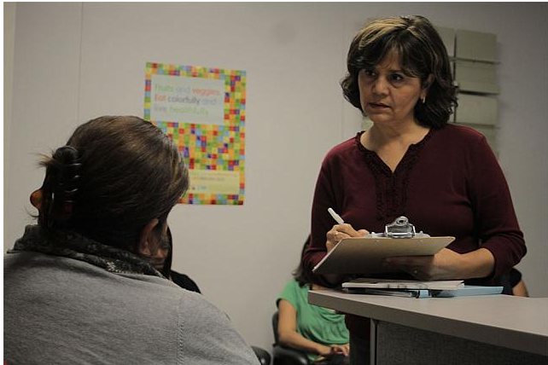 | WIC Codes  IMG_1294.JPG  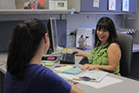

Module 3 Page: Section A – Gathering Anthropometric Information

Narrative:
The A in the A section of the Nutrition Assessment stands for Anthropometric, which refers to measurements of height, weight, and information about prematurity.

You’ve already learned how to collect anthropometric data, and that’s a great start. Next, on the ABCDE Guide under the A section, you’ll find a few questions. These questions will help you talk to mom and probe for important information you will need to complete the A part of the nutrition assessment. You’ll ask these questions as you do your testing.

You’ll review growth and weight gain data to assess for any clues to your client’s needs. You’ll look at the data, as well as uncover mom’s feelings on the subject in order to get a sense of whether there is any growth related concerns and what diet questions you may need to ask. Often, the answers to questions about weight and height can help you to uncover information such as:
- Have the mother and child been eating well?
- Is mom aware of and concerned about weight issues?
- What kinds of challenges might stand in the way of educating or supporting new behaviors?

Design:

A Stands for Anthropometric
Anthropometric: Height, Weight, BMI, Prematurity

Leave chart up, remove labels and show picture of mom and the following label:
Questions Will Help You Talk to Mom and Probe for Important Information

Remove chart, leave mom up; add the following labels one by one:
Have the Mother and Child Been Eating Well?
Is Mom Aware of Concerned about Weight Issues?
What Kinds of Challenges Might Stand in the Way of Educating or Supporting New Behaviors?

Interaction: None

Graphics/Media

A Stands for Anthropometric  [A section of ABCDE Chart]  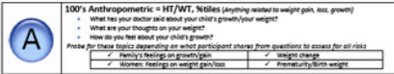 | Open-Ended Questions  iStock 000015200103

Module 3 Page: Section A – Three Open-ended Questions

Narrative:
There are three open-ended questions on the Anthropometric section of the Nutrition Assessment Chart. These may not be the only questions you’ll ask, but they provide a great way to start gathering information that goes beyond simple measures of weight and height.

The questions you’ll be asking are different from simple data collection. They are open-ended, probing questions intended to help you better understand the client’s thoughts, feelings, and experience. Your job is to help your client to share clues about her challenges and needs. You’ll use your active listening and OARS skills to help you as you probe for information that can’t be measured.

As your client answers these questions, you’ll decide whether to take notes and move on to the next step of the Assessment, or probe a little more deeply. We’ll be exploring how to make this decision, and how to ask follow up questions.

Click the tabs to learn how to ask each question.

Design

Chatting with client in lab
Open-ended Questions Help You Collect Clues

Listening to emotional client
Probing Questions Help You Understand Your Client
Help Your Client Share Information That Can’t Be Measured

Taking Notes
You’ll Decide Whether to Take Notes or Probe More Deeply
Learn How This Decision Is Made

Show thumbnail images of the 3 layers photos, make them buttons and when clicked on, open a new layer that will include a larger photo and the text and a close button.
USE LAYERS:

Tab 1: What has your doctor said about your/your child’s growth? – This is a great question that will help you find out about what the client’s doctor thinks about their child’s weight or growth. Listen carefully to the answer. If the client says the doctor is concerned, follow up with a request to “tell me more about that.” Probe more deeply if you feel that additional information would help you better serve your client’s needs. Why is the doctor concerned? Does the mother agree? Why or why not? Take notes, and remember to come back to this later in the assessment.

Tab 2: What are your thoughts about your/your child’s weight? – This question will help you to better understand Mom’s feelings about her own or her child’s weight. Does mom believe there is an issue? How do her feelings match your anthropometric measurements? If mom is concerned, follow up with a request to “tell me more about that.” Continue to probe until, based on your professional judgment, you have a full picture of the situation. Take a note of this to come back to later on during your assessment.

Tab 3: How do you feel about your child’s growth? – This question will help you to better understand Mom’s feelings about her child’s growth. Does mom believe there is an issue? How do her feelings match your anthropometric measurements? If mom is concerned, follow up with a request to “tell me more about that.” Does mom have specific reasons for her concern? If mom is worried, take a note of this to come back to later on during your assessment.

Interactions: Click on tabs to see layers (details under “design”)

Media/Graphics:

chat with client in lab  istockphoto 6430674  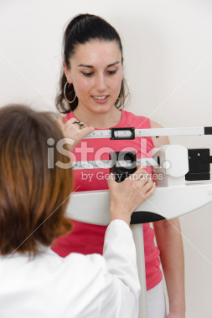 | listen  17387526 | take notes  istock 8263617
Layer 1  iStock 000014570633 | Layer 2  iStock 000003090783 | Layer 3  iStock 000004395368  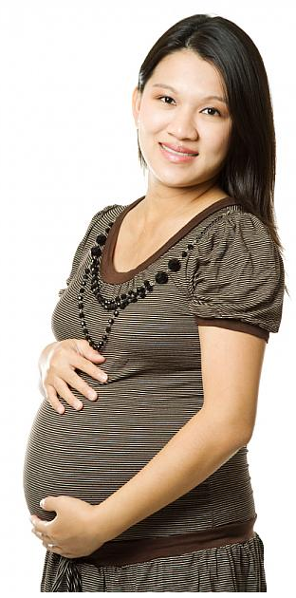

Module 3 Page 10: How the Right Questions Provide the Answers You Need

Narrator: How can asking the right questions in the right way help you to get the information you need? By exploring your client’s feelings about health and nutrition issues, you’ll gain a much better understanding of what your client knows about these issues and what nutrition education and messages to offer her. By probing when it’s appropriate, you’ll get a much better sense of your client’s real situation.

Imagine you’ve just weighed and measured a pregnant mom and her young child. You’ve learned some important facts. But you haven’t yet figured out what they mean relative to this particular client.

- What does this client think about her weight or her child’s growth?
- Does she have concerns or questions that you could answer through education?
- Has she shared information about her motivations or desires?

The more you know about your client, the better you’ll be able to pinpoint just what she needs – and when she needs it.

Design:

Pregnant Mom
The Right Questions Provide Useful Information
By Exploring Mom’s Feelings You Learn What She Knows and How She Thinks
You’ll Know Which Nutrition Education and Messages to Share

Happy Pregnant Mom
Weighing and Measuring Is One Important Step

Worried Pregnant Mom
What Does She Think about Her Weight or Her Child’s Growth?
Does She Have Concerns or Questions?
What Are Her Motivations and Desires?

_____________________________________________________________________________

Interactions: None

Graphics/Media:

pregnant mom  iStock 000001495171  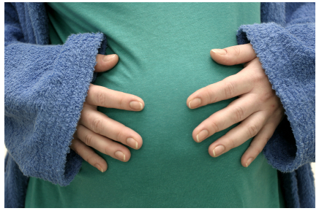 | happy and pregnant  iStock 000007393949  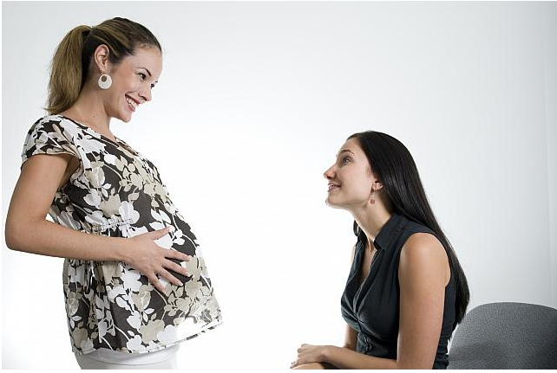 | worried and pregnant  iStock 000011729297  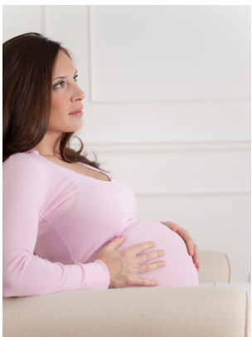

Module 3 Page 11: How the Right Questions Provide the Answers You Need

Narrator: Watch the video carefully; it will help you better understand how to assess your client as you complete anthropometric measurements. It will also give you some insights into how best to ask questions, provide support and affirmations, and make a connection with your client.

Design

Narrator
Watch the Video to See How to Ask Questions
Learn to Make a Connection with Your Client

[video script:
Setting: Lab space at WIC. Pregnant client is sitting in a chair; young child is with her. WIC counselor is completing measurements. Both mother and child are visibly overweight.]
Counselor: OK, I’m just going to collect some information about your height and weight and your child’s growth as well.
[squats to child’s height; speaks to child] Ok [name of child], I’m just going to ask you to come and step onto this scale, and it will tell me just how tall you are and how much you weigh! Take your shoes off and stand on this piece of paper, stand all the way back and stand up straight and tall.
Great job! Wow, look how tall you are! We’re going to do that one more time to be sure we know exactly what to write down.
OK, and now we’re going to check your weight, so come right over here and climb up… Great! Now climb off, and we’ll do that one more time.
OK, and now I’m going to ask Mom to come on over, and we’ll do just the same thing. Do you know what your weight was before you became pregnant this time?
Mom: I’m not sure… I’ve always had a lot of curves, you know, so maybe a little overweight. [mom and counselor laugh]
[as she’s measuring mom] And has the doctor said anything to you about your child’s growth or your weight?
Mom: Not really, I don’t think so.
Counselor: And did you have any thoughts or concerns about growth or weight for either you or [name of child]?
Mom: No, I think we’re doing just fine.
Counselor: [making notes on chart] OK, great, then let’s go and check your iron levels!

Interaction:
Graphics/Media:
Melanie (narrator)
#12020, Melanie

Video auto plays after audio

Module 3 Page 12: What WIC Codes Came Up?

Narrator: As you finish up the A, or Anthropometric portion of the Nutrition Assessment, you’ll be adding WIC Codes to your client’s file, using HANDS. All Anthropometric WIC Codes are numbered in the 100s. There are WIC Codes for each of the 4 main client categories; infants, children, pregnant women and postpartum women. Some WIC codes may indicate the need for a referral.

During the video, the WIC counselor weighed and measured both the client and her child. The client is in her second trimester of pregnancy. Here’s what the counselor found:

- The mother was overweight prior to her pregnancy
- The mother now has a high BMI relative to her height and stage of pregnancy
- The child has a high BMI

Design
Typing at a computer
Anthropometric WIC Codes Are Numbers in the 100’s
There are WIC Codes for Infants, Children, Pregnant Women, and Postpartum Women

Still from video
The WIC Counselor Weighed and Measured Mother and Child

Scale
Mom Was Overweight Prior to This Pregnancy
Mom Has a High BMI Relative to Her Height and Stage of Pregnancy
The Child Has a High BMI

Interaction

None

Graphics/Media

still from video | scale  Thinkstock file 10815261
Module 3 Page 13: Self Check 2

Narrator: Based on the information in the last screen, which WIC Codes would you assign to this client and her child? Then click the ‘SUBMIT’ button to check your answer.

Design:

Multiple Choice Question

Based on the information in the last screen, which WIC Codes would you assign to this client and her child? Then click the ‘SUBMIT’ button to check your answer.

- Risk 111 comes up for mom, risk 114 comes up for child
- Risk 111 and 133 comes up for mom, risk 114 comes up for child
- Risk 133 comes up for mom, no risk comes up for child
- Risk 114 comes up for mom, risks 111 and 133 come up for child

Feedback:

Correct! Mom has two WIC codes related to being overweight before and during pregnancy. Her child has a WIC code for being overweight as well.

Incorrect. Check the information again, and be sure to include all the correct codes.

Incorrect. Mom’s WIC codes re 111 and 133; her child’s WIC codes is 114.

Interactions:
MC Question

Graphics/Media: MC question

Module 3 Page 14: Self Check 3

Narrative: Which of the following are true of WIC Codes? (Select all that are correct.) Then click the ‘SUBMIT’ button to check your answers.

Design:

This is a multiple choice quiz with MULTIPLE CORRECT ANSWERS.

Interactions:

Which of the following are true of WIC Codes? (Select all that are correct.) Then click the ‘SUBMIT’ button to check your answers.

- WIC Codes are entered into HANDS
- WIC Codes may indicate a need for a referral
- There are different WIC Codes for different groups of clients
- All WIC Codes must be entered by a doctor

[Feedback:

Correct! WIC Codes are entered into HANDS, and may indicate a need for a referral. There are different WIC Codes for different groups of clients.

Incorrect. WIC Codes need not be entered by a doctor. Try again!

Incorrect. WIC Codes are entered into HANDS, and may indicate a need for a referral. There are different WIC Codes for different groups of clients.

Media/Graphics:

Multiple choice template

Module 3 Page 15: Self Check 4
Narrative: Write the correct word to complete the sentence. Then click the ‘SUBMIT’ button to check your answer.

Design: This is a fill-in-the-blank assessment exercise.

Interaction:

[Instructions: Write the correct word to complete the sentence. Then click the ‘SUBMIT’ button to check your answer.
]
Create a SUBMIT button.

Learners fill in the blank, then click SUBMIT to see if their answers is correct. They have three tries.

QUESTION: WIC Codes that are in the 100’s always relate to _________ measurements.

ANSWER: Anthropometric

[Feedback:
- Correct! WIC Codes that are in the 100’s always relate to Anthropometric measurements.
- Incorrect. Try again.
- Incorrect. WIC Codes that are in the 100’s always relate to Anthropometric measurements. ]

Module 3 Page 15: Reflecting on Open Ended Questions
Narrative: Think back to the video and the questions the counselor asked. They included:
- Do you know what your weight was before you became pregnant this time?
- Has the doctor said anything to you about your child’s growth or your weight?
- Did you have any thoughts or concerns about growth or weight for either you or [name of child]?
Despite the fact that measurements show several WIC risk factors, neither the client nor her doctor expressed concerns. The client did not ask for any additional information.
The counselor did not probe further at this point.

Design

Stills from video
The Counselor Asked Open-ended Questions

What Was Your Pre-Pregnancy Weight?
Has the Doctor Said Anything about Your Child’s Growth or Your Weight?
Did You Have Any Thoughts or Concerns about Growth or Weight for Either You or [name of child]?
Interaction
None
Graphics/Media
Still images from video

Module 3 Page 16: Self Check 5

Narrative: Which of the following clues did the counselor pick up from the answers she received to open-ended questions? (Select all that are correct.) Then click the ‘SUBMIT’ button to check your answer.

Design:

This is a multiple choice quiz with MULTIPLE CORRECT ANSWERS.

Interactions:

Which of the following clues did the counselor pick up from the answers she received to open-ended questions? (Select all that are correct.) Then click the ‘SUBMIT’ button to check your answer.

- The client has a family history of obesity
- The client has been overweight for an extended period of time
- The client’s doctor has not raised red flags for high BMI
- The client does not seem to be aware that overweight increases health risks

[Feedback:

Correct! The counselor learned some specific facts about her client, and picked up an important clue: the client does not seem to be aware of or concerned about the risks related to being overweight.

Incorrect. If you’re not sure of the answer, you might want to go back and rewatch the video.

Incorrect. The counselor learned some specific facts about her client, and picked up an important clue: the client does not seem to be aware of or concerned about the risks related to being overweight.

Media/Graphics:

Multiple choice template

Module 3 Page Section B – Gathering Biochemical Information

Narrative: The B in the ABCDE Nutrition Assessment Guide stands for biochemical, which refers to anything related to blood, such as iron or lead levels.

You’ve already learned how to collect biochemical data, and that’s a great start. Next, on the ABCDE Guide under the B section, you’ll find questions to ask as you complete blood work. Just as in section A, you’ll ask these questions to probe for important information about your client. These questions can help you collect important information about your client such as:

- If iron is an issue, is the client’s doctor concerned about or addressing that issue?
- If the client is anemic, does she understand what that means for herself or her children?
- Does the client understand that anemia can be addressed through diet?
- Does the client understand the dangers connected with lead poisoning? Has she taken steps to check for lead issues?

Design:
Insert Icon for Second Step along the path to assessment
Show ABCDE chart with only B being saturated and fade down a little the other parts
B Stands for Biochemical
Measures of Iron and Lead in the Blood

Leave chart up, remove labels and show picture of mom and the following label:
Questions Will Help You Talk to Mom and Probe for Important Information

Remove chart, remove mom and bring mom back up for the following labels:
Is Your Client Aware of Any Existing Issues with Anemia?
Does Your Client Understand the Problems That Can Be Caused by Anemia?
Does Your Client Understand the Problems That Can Be Caused by Lead?
Does Your Client Know How to Address These Potential Problems?

Interaction: None

Graphics/Media

Icon for Biochemical step along the assessment path | Open-Ended Questions  iStock 21344296

Module 3 Page Section B – Three Open-Ended Questions

Narrative: There are three open-ended questions on the Biochemical section of the ABCDE Nutrition Assessment Chart. The answers to these questions will not only give you basic information about your client’s physical condition, they will also give you clues to her knowledge level, concerns, and challenges.

As your client answers these questions, you’ll decide whether to take notes and move on to the next step of the Assessment, or probe a little more deeply.

Click the tabs to learn how to ask each question.

Design

Mom with Child
Three Open-ended Questions
Collect More Clues about Your Client’s Needs and Concerns

Show thumbnail images of the 3 layers photos, make them buttons and when clicked on, open a new layer that will include a larger photo and the text and a close button.

USE LAYERS:
Tab 1: What has your doctor said about your iron level or your child’s iron level? – This question will help you find out about what the client’s doctor thinks about the client’s iron level. Listen carefully to the answer. If the client says the doctor is concerned, follow up with a request to “tell me more about that.” Probe more deeply if you feel that additional information would help you better serve your client’s needs. For example, you might learn that the client does not know for sure whether her child has had his iron tested or what the results were. Or you might find that the client knows about low iron issues but hasn’t taken any action to change the situation. Take notes, and remember to come back to this later in the assessment.

Tab 2: What do you know about anemia? -- This question is a lead-in to a possible conversation about the impact of anemia on a child’s growth and welfare. If Mom understands anemia it’s fine to move on – but if not, continue to probe until, based on your professional judgment, you have a full picture of the situation. Take a note of this to come back to later on during your assessment.

Tab 3: Have you or your child had a lead test before? -- Like the question about anemia, this question has the potential to lead into a conversation about the impact of lead on a child’s development. It might also lead to new clues about your client’s knowledge level and concerns. Is she worried about the condition of her living place? If mom is concerned, follow up with a request to “tell me more about that.” Does mom have specific reasons for her concern? If mom is worried, take a note of this to come back to later on during your assessment

Interactions: Click on tabs to see layers (details under “design”)

Media/Graphics:

intro with labels  Stock Photo: 37688578 | Layer 1  iStock 000013008105  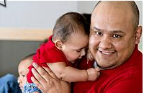
Layer 2  iStock 000019080675  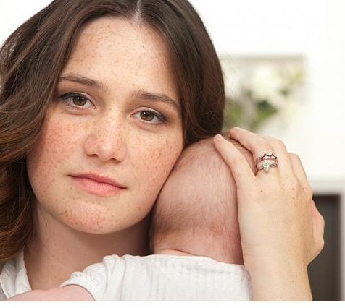 | Layer 3  Video 7 3

Module 3 Page: Biochemical Assessment in Action

Narrator: Watch the video carefully; it will help you better understand how to assess your client as you complete the biochemical measurements. It will also give you some insights into how some of your questions can provide clues about your client’s needs and concerns.

Design

Narrator:
You’ll Better Understand How to Assess Your Client
You’ll Collect More Clues about Your Client
[video script – using Massimo]
Counselor: [as mom sits down] OK, why don’t you have a seat right here, and we’re going to be checking your iron. We’ll start with [child’s name], if that’s okay? (Childs name) can you sit her on your mom’s lap? Thank you! This machine here is going to tell me about the iron you have in your body. I’m going to slide this clip on your finger like this, and you get to be really still while it checks your iron. It won’t hurt a bit! Great work, you’re super brave!
Mom now it’s your turn. Let me measure to see if I can use the same finger clip for you. Ok looks good. I’ll clip this onto your finger. Please try to be as still as possible as it reads your iron levels.
Now, what I’m doing is checking the iron level in your blood. Has your doctor said anything about that? [mom shakes head “No”] Iron has a lot to do with brain development and growth, so it’s very important to have enough iron in your diet.
[checks numbers turns to mom]
Have you ever heard of anemia?
Mom: No, is it a bad thing?
Counselor: Well, anemia means low iron levels in the blood, and both of you came up a little low. Iron has a lot to do with brain development and growth, so it’s very important to make sure you have good levels in your blood.
Mom: So does that mean we have anemia?
Counselor: We don’t diagnose anemia here, but I’d recommend you see your doctor and have him look into that for you. Food is a great source of iron so we can discuss some healthy foods that you can eat to help increase your iron levels. If you’d like, I’ll make a note so that later in the appointment we can talk about increasing iron in your diet so you and your family can get all the nutrition you need to ensure you’re getting enough iron in your diet. Is that ok? [mom says yes; counselor makes a note in her chart]
Counselor: [straightening up lab] And have you and your daughter had a lead test?
Mom: No, not that I know of…should we?
Counselor: Well, next time you’re at your doctor’s office it’s a great idea to ask about a lead test, because some things around the house might contain lead and you wouldn’t even know, and that can be harmful to you or your child.
Mom: OK, I’ll remember to do that.
Interaction:
Video starts on click
Graphics/Media:
Narrator
#11898, Melanie

Video to come

Module 3 Page: Self Check 6

Narrative: Which of the following clues did the counselor pick up from the answers she received to open-ended questions? You may choose more than one correct answer. Then click the ‘SUBMIT’ button to check your answer.

Design:

This is a multiple choice quiz with MULTIPLE CORRECT ANSWERS.

Interactions:

Which of the following clues did the counselor pick up from the answers she received to open-ended questions? You may choose more than one correct answer. Then click the ‘SUBMIT’ button to check your answer.

- The client’s pediatrician conducted lead tests and found no issues
- The client is open to learning about how to increase iron in her family’s diet
- The client already understands the possible issues connected with anemia
- The client is concerned about test results that show low iron levels

[Feedback:

Correct! The counselor learned that the client is concerned about low iron levels in her blood and her child’s blood, and that the client is open to learning how to increase iron in her family’s diet.

Incorrect. If you’re not sure of the answer, you might want to go back and rewatch the video.

Incorrect. The counselor learned that the client is concerned about low iron levels in her blood and her child’s blood, and that the client is open to learning how to increase iron in her family’s diet.

Media/Graphics:

Multi-answer multiple choice template

Module 3 Page: What WIC Codes Came Up?

Narrator: As you finish up the B, or biochemical portion of the Nutrition Assessment, what WIC codes can you identify that have come up? You’ll be entering the WIC Codes in HANDS. All biochemical WIC Codes are numbered in the 200s.

During the video, the WIC counselor checked both the client and her child and found that both had low levels of iron in their blood. She also asked about whether they had been tested for lead and found that they had not.

Design
Image from HANDS
Enter Biochemical Data into HANDS So It Can Generate the Necessary Codes
Biochemical WIC Codes Are Numbered in the 200’s

Still from video
The WIC Counselor Tested for Iron Levels in the Blood
Both Mother and Child Had Low Iron Levels

Interaction

None

Graphics/Media

image from HANDS | Still from video

Module 3 Page: Self Check 7

Narrator: Based on the information in the last screen, which WIC Codes would you assign to this client and her child? Then click the ‘SUBMIT’ button to check your answer.

Design:

Multiple Choice Question

Based on the information in the last screen, which WIC Codes would you assign to this client and her child? Then click the ‘SUBMIT’ button to check your answer.

- WIC Code 201 comes up for mom, WIC Code 211 comes up for child
- WIC Code 201 comes up for mom and child
- WIC Code 211 comes up for mom, no WIC Code comes up for child
- WIC Code 211 comes up for mom, WIC Code 201 comes up for child

Feedback:

Correct! Both Mom and child have WIC Code 201, for low hemoglobin.

Incorrect. Check the information again, and be sure to include all the correct codes.

Incorrect. Both Mom and child have WIC Code 201 for low hemoglobin.

Interactions:
MC Question

Graphics/Media: MC question

Module 3 Page: Self Check 8

Narrative: True or false, if your client or her child has not been tested for lead, you should perform the test at the WIC lab. Click the ‘SUBMIT’ button to check your answer.

Design:

This is a true/false quiz.

Interactions:

True or false, if your client or her child has not been tested for lead, you should perform the test at the WIC lab. Click the ‘SUBMIT’ button to check your answer.

True
False

[Feedback:

Correct! You should recommend that your client ask her doctor to perform a lead test.

Incorrect. You should recommend that your client ask her doctor to perform a lead test.

Media/Graphics:

True/False template

Module 3 Page: Self Check 9
Narrative: Write the correct word to complete the sentence. Then click the ‘SUBMIT’ button to check your answer.

Design: This is a fill-in-the-blank assessment exercise.

Interaction:

[Instructions: Write the correct word to complete the sentence. Then click the ‘SUBMIT’ button to check your answer.]
Create a SUBMIT button.

Learners fill in the blank, then click SUBMIT to see if their answers is correct. They have three tries.

QUESTION: In the lab, WIC counselors test for _______ levels in clients’ blood.

ANSWER: Iron

[Feedback:

Correct! WIC biochemical testing checks for iron levels in the blood.

Incorrect. Try again.

Incorrect. WIC biochemical testing checks for iron levels in the blood.

Module 3 Page Section C – Gathering Clinical Information
Narrative: The C in the ABC& E section of the Nutrition Assessment stands for clinical, which refers to the collection of medical information about your client and any children she has. The clinical part of the Assessment does not involve any hands-on testing; instead you’ll use some open-ended questions, and probing as necessary to find out more about your client’s medical status.

The questions in section C can help you collect important information about your client such as:

- If your client is pregnant, are there any health concerns related to the pregnancy?
- If the client has seen a doctor, has the doctor expressed any concerns related to the health of the client or her children?
- What is the status of the client’s oral health and immunizations history?
- Are there medical worries or concerns that might be related to diet or nutrition?

Design:
Show ABCDE chart with only C being saturated and fade down a little the other parts
C Stands for Clinical
Collecting Information about Health and Medical Conditions
Leave chart up, remove labels and show picture of mom and the following label:
Questions Will Help You Talk to Mom and Probe for Important Information

Remove chart, remove mom and bring mom back up for the following labels:

If your client is pregnant, are there any health concerns related to the pregnancy?
If the client has seen a doctor, has the doctor expressed any concerns related to the health of the client or her children?
What Is the Status of the Client’s Oral Health and Immunizations History?
Are there medical worries or concerns that might be related to diet or nutrition?

Interaction: None

Graphics/Media

Icon for Biochemical step along the assessment path | ABCDE Chart focusing on C | Open-Ended Questions  iStock 34868980

Module 3 Page Section B – Three Open-Ended Questions

Narrative: There are three open-ended questions on the Clinical section of the ABCDE Nutrition Assessment Chart. Answers to these questions will help you determine whether to probe further, and how much information you need to collect. Sometimes, you’ll collect information that you’ll be able to use later as you explore your client’s particular concerns, needs, and challenges.

Click the tabs to learn how to ask each question.

Design

Mom with Child
Three Open-ended Questions
Collect More Clues about Your Client’s Needs and Concerns

Show thumbnail images of the 3 layers photos, make them buttons and when clicked on, open a new layer that will include a larger photo and the text and a close button.

USE LAYERS:
Tab 1: What has your doctor said about your pregnancy/baby/child? – The answer to this question will help you decide whether to probe further about specific medical issues. Listen carefully to the answer. If the client says the doctor is concerned, follow up with a request to “tell me more about that.” Probe more deeply if you feel that additional information would help you better serve your client’s needs. For example, you might ask about specific concerns listed on the ABCDE chart, such as the status of your client’s prenatal care. You might probe to be sure you’ve uncovered any issues related to a child’s health, asking “How about your child’s oral health? Has he seen a dentist recently?” Your goal is to be sure you have answers to each topic listed on the chart.

Tab 2: Do you have any concerns in regards to health for you/baby/child? -- This question is a lead-in to a discussion about how the client feels about health related issues. The answers will provide you with important insight into what the client cares about, what her motivations are, and how she might respond to nutrition education. Continue to probe with open-ended questions until you feel you have enough information to assess your client’s concerns and needs. Take notes about what you’ve learned, and come back to them later on during your assessment.

Tab 3: How does this pregnancy compare to your previous pregnancies? – If your client is pregnant and has had children before, answers to this question will help you probe into any changes in health or nutritional status. If the pregnancy is very much the same as prior pregnancies, it would suggest that your client’s status is stable. If new issues have arisen, now is a good time to probe into the reasons. If you haven’t already asked, use the list of topics in the ABCDE chart to guide the conversation. Be sure you have answers to questions about prenatal care, nausea or vomiting, previous pregnancies, medical history, medications, allergies, and oral/dental health. If mom is worried, take a note of this to come back to later on during your assessment

Interactions: Click on tabs to see layers (details under “design”)

Media/Graphics:

Intro  iStock 000011729297  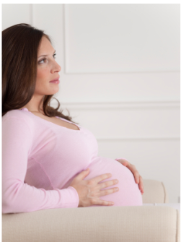 | Layer 1  iStock 000007393949  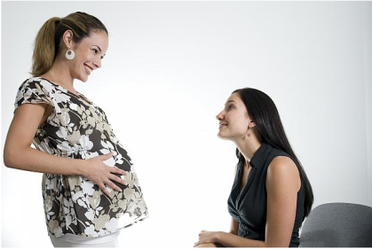
Layer 2  postpartum woman  iStock 000011895685 | Layer 3  pregnant woman  iStock 000014616169  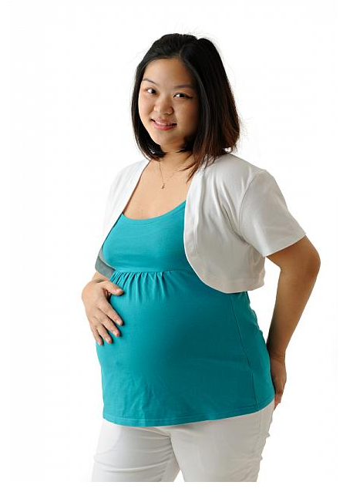

Module 3 Page: Clinical Assessment in Action

Narrator: Watch the video carefully; it will help you better understand how to assess your client as you complete the biochemical measurements. It will also give you some insights into how some of your questions can provide clues about your client’s needs and concerns.

Design

Narrator:
You’ll Better Understand How to Assess Your Client
You’ll Collect More Clues about Your Client

[video script – Counselor is tidying up after using Massimo, etc.]
Counselor: So congratulations on the baby! What has your doctor said about your pregnancy? Is everything going well?
Client: The doctor says the baby is doing great and the ultrasound was good and heartbeat sounds good too.
Counselor: Hey, that’s terrific. A lot of moms have issues like gestational diabetes… is that something your doctor has mentioned?
Client: Oh, yeah, I do have that, but I had it with my last pregnancy and I did great.
Counselor: What did the baby weigh at birth?
Client: The baby was really big – 10 pounds one ounce, I think!
Counselor: Wow! But you managed it – that’s awesome! OK, so how are you handling the gestational diabetes this time around?
Client: Well, my doctor told me what I should eat…
Counselor: So you’re managing it with changes to your diet?
Client: Yeah. I’m doing my best.
Counselor: Great! So, some moms do get very tired when they’re pregnant; is that a problem for you?
Client: Oh, yeah, I’m definitely tired. But you know, there’s a lot to do, especially with a toddler around!
Counselor: And what does the doctor say about [name of child]? How is he/she doing?
Client: We saw his/her doctor just a couple of months ago, and the doctor says he/she is doing great.
Counselor: Any issues with allergies? [Client shakes her head] How about dental health, any problems?
Client: No, we’re fine.
Counselor: And are either of you on any medications?
Client: Just my prenatal vitamins!
Counselor: Oh, that’s great. It’s so important, and you’re giving your baby a great start.

Counselor:
Interaction:
Video starts on click
Graphics/Media:
Narrator
#11898, Melanie

Video to come

Module 3 Page: Self Check 10

Narrative: Which of the following clues did the counselor pick up from the answers she received to open-ended questions? You may choose more than one correct answer. Then click the ‘SUBMIT’ button to check your answers.

Design:

This is a multiple choice quiz with MULTIPLE CORRECT ANSWERS.

Interactions:

Which of the following clues did the counselor pick up from the answers she received to open-ended questions? You may choose more than one correct answer. Then click the ‘SUBMIT’ button to check your answers.

- The client is worried about her gestational diabetes.
- The client’s first pregnancy resulted in an unusually large baby.
- The client is experiencing fatigue with her pregnancy.
- The client’s child has allergies.
- The client’s child has visited the doctor this year.

[Feedback:

Correct! The counselor learned, among other things, that the client has gestational diabetes but is not worried about it. She also learned that the client’s first pregnancy resulted in a very large baby; that mom is experiencing fatigue with this pregnancy; and that her child visited the doctor this year.

Incorrect. If you’re not sure of the answer, you might want to go back and rewatch the video.

Incorrect. The counselor learned, among other things, that the client has gestational diabetes but is not worried about it. She also learned that the client’s first pregnancy resulted in a very large baby; that mom is experiencing fatigue with this pregnancy; and that her child visited the doctor this year.

Media/Graphics:

Multi-answer multiple choice template

Module 3 Page: What WIC Codes Came Up?

Narrator: As you finish up the C, or Clinical portion of the Nutrition Assessment, what WIC codes can you identify that have come up for mom? You’ll be entering the WIC Codes in HANDS. All Clinical WIC Codes are numbered in the 300s.

During the video, the WIC counselor learned that mom had had gestational diabetes during her last pregnancy, and has it again with this pregnancy. She also learned that mom’s first child was born at over 10 pounds.

Design
Image from HANDS
Enter Biochemical data into HANDS so it can generate the necessary codes
Biochemical WIC Codes Are Numbered in the 300’s

Still from video
Mom had gestational diabetes during her last pregnancy.
Mom has gestational diabetes during this pregnancy.
Mom’s first child weighed over ten pounds at birth.

Interaction

None

Graphics/Media

image from HANDS | Still from video

Module 3 Page: Self Check 11

Narrator: Based on the information in the last screen, which WIC Codes would you assign to this client? Then click the ‘SUBMIT’ button to check your answer.

Design:

Multiple Choice Question

Based on the information in the last screen, which WIC Codes would you assign to this client? Then click the ‘SUBMIT’ button to check your answer.

- WIC Codes 302, 303, 339
- WIC Codes 303, 337
- WIC Codes 302, 337
- WIC Codes 302, 303, 337

Feedback:

Correct! Mom has WIC Codes 302, 303, 337 because of past and present gestational diabetes and because her first baby weighed more than 10 pounds.

Incorrect. Check the information again, and be sure to include all the correct codes.

Incorrect. Mom has WIC Codes 302, 303, and 337 because of past and present gestational diabetes and because her first baby weighed more than 10 pounds.

Interactions:
MC Question

Graphics/Media: MC question

Module 3 Page: Self Check 12

Narrative: True or false, if you are interviewing a client about her medical history and status, you should ask about her parents’ medical history as well. Then click the ‘SUBMIT’ button to check your answer.

Design:

This is a true/false quiz.

Interactions:

True or false, if you are interviewing a client about her medical history and status, you should ask about her parents’ medical history as well. Then click the ‘SUBMIT’ button to check your answer.

True
False

[Feedback:

Correct! When interviewing a client you should ask about her medical history and status, but you do not need to ask about her parents’ medical history.

Incorrect. When interviewing a client you should ask about her medical history and status, but you do not need to ask about her parents’ medical history.

Media/Graphics:

True/False template

Module 3 Page Section E – Gathering Environmental Information
Narrative: The E in the ABC& E section of the Nutrition Assessment stands for environment, and refers to the collection of information about your client’s living situation. This portion of the assessment is quite brief, and includes just three questions. The E section is particularly important, though, because it can help you collect critical information about your client by asking these questions:

- Does anyone in the house smoke?
- What are your concerns about your/your child’s safety?
- What concerns do you have about drugs or alcohol?

If you do learn that your client is living in an abusive or dangerous situation, you will need to address those issues immediately rather than continuing with the nutritional assessment.
Design:
Insert Icon for Sixth Step along the path to assessment
Show ABCDE chart with only E being saturated and fade down a little the other parts
E Stands for Environmental
Collecting Information about Smoking, Drug Abuse, and Related Issues

Leave chart up, remove labels and show picture of mom and the following label:
Questions Will Help You Talk to Mom and Probe for Important Information

Remove chart, remove mom and bring mom back up for the following labels:
Does anyone in the house smoke?
What are your concerns about your/your child’s safety?
What concerns do you have about drugs or alcohol?

Interaction: None

Graphics/Media

Icon for Environmental step along the assessment path | ABCDE Chart focusing on E | Open-Ended Questions  istock photo 21327650
Module 3 Page: Environmental Assessment in Action

Narrator: Watch the video carefully. How does the interviewer uncover clues about the client’s environment?

Design

Narrator:
Watch the Video to Collect Clues About the Client’s Environment
[video script –

Counselor: So tell me a little about your living situation.

Client: Oh, I live with my brother.

Counselor: That sounds nice.

Client: It is. We like it.

Counselor: And does anyone in your house smoke?

Client: That’s the only problem – my brother is a smoker.

Counselor: And how about you?

Client: No, I don’t smoke.

Counselor: That’s great! And do you have any concerns about your safety at home – any worries about alcohol or drug abuse?

Client: Oh, no, definitely not.

Counselor: Wonderful, that’s good to hear.]

Interaction:

Video (to come) autoplays

Media/Graphics

Narrator
Image 11915

Module 3 Page: Self Check 13

Narrator: Based on the information in the last video, the WIC counselor assigned the client and her child WIC Code 904. Which of the following explains her decision? Then click the ‘SUBMIT’ button to check your answer.

Design:

Multiple Choice Question

Based on the information in the last video, the WIC counselor assigned the client and her child WIC Code 904. Which of the following explains her decision? Then click the ‘SUBMIT’ button to check your answer.

- The client lives with her brother.
- The client lives with a smoker.
- The client did not mention her children’s father.
- The client does not feel safe at home.

Feedback:

Correct! WIC Code 904 identifies the client as living with a smoker.

Incorrect. Check the information again, and be sure to include all the correct codes.

Incorrect. WIC Code 904 identifies the client as living with a smoker.

Interactions:
MC Question

Graphics/Media: MC question

Module 3 Page: Self Check 14

Narrative: True or False, the environmental portion of the Nutrition Assessment includes questions about the client’s physical safety in the home. Then click the ‘SUBMIT’ button to check your answer.

Design:

This is a true/false quiz.

Interactions:

True or False, the environmental portion of the Nutrition Assessment includes questions about the client’s physical safety in the home. Then click the ‘SUBMIT’ button to check your answer.

True
False

[Feedback:

Correct! The environmental portion of the Nutrition Assessment includes questions about physical safety as well as drug and alcohol abuse.
Incorrect. The environmental portion of the Nutrition Assessment includes questions about physical safety as well as drug and alcohol abuse.

Media/Graphics:

True/False template

Module 3 Page Wrapping Up and Moving On
Narrative: Congratulations! You’ve learned how to use the ABCDE Guide in the lab to ask the right questions and help your client get the resources she needs. You’ve learned how to keep your questions open-ended, how to probe for additional information, and how to assign WIC Codes when appropriate.

Now, it’s time to leave the lab. You and your client will head to your office to complete the D, or Diet, portion of the Nutrition Assessment. We’ll spend quite a bit of time exploring this part of the Nutrition Assessment because it’s a little different from the A, B, C and E portions of the Assessment.

You’ll use several fun, interactive tools to help your client open up and share her thoughts and concerns about nutrition. You’ll collect important information about your client’s motivations and her readiness to make changes in her family’s nutritional status. Once you’ve completed the D portion of the Assessment, you’ll be ready to start preparing recommendations, referrals, and a nutrition package that’s just right for your client’s present needs.

Are you ready to get started? Click “Next” to continue to Module 4!

Design:
Show Melanie (narrator
Congratulations! You Know How to Use the ABCDE Chart in the Lab
You Know How to Ask the Right Open-Ended Questions
You Know How to Probe for Additional Information
You Know How to Assign WIC Codes
Show ABCDE chart with D being saturated and fade down a little the other parts
Next You’ll Learn to Use the D Portion of the Guide
D Stands for Diet
Collecting Information about Smoking, Drug Abuse, and Related Issues

Icon for Section D
You’ll Learn to Use Fun, Interactive Tools to Collect Information
Your Client Will Share Thoughts and Feelings About Nutrition
You’ll Assess Your Clients Needs, Concerns, Motivations, and Readiness for Change

Melanie
Let’s Get Started!
Click on NEXT to Continue to Module 4

Include NEXT button with text “Click on NEXT and let’s continue to Module 4!”

Interaction: Click on NEXT for Module 4

Graphics/Media

Melanie 11905 | ABCDE Chart focusing on D | Icon for section D | Melanie 11909

